**COP 5615 Fall 2014**

**Distributed Operating Systems**

**Alin Dobra**

**Project 1**

**Mining Bit coins with given number of leading zeroes by implementing actor model using Akka and Scala**

**Submitted By:**

**Team Member : 1**

**Name : Abhishek Singh Panesar**

**Email :** [**asp.abhi18@ufl.edu**](mailto:asp.abhi18@ufl.edu)

**UFID : 5111-8921**

**Team Member : 2**

**Name : Nishit Sadhwani**

**Email :** [**n.sadhwani@ufl.edu**](mailto:n.sadhwani@ufl.edu)

**UFID : 5393-5598**

**------------------------------------------------------------------------**  
How to run the code  
**------------------------------------------------------------------------**  
You will require

Java version of lower than 1.8, i.e Java verion 1.7 or lower.  
You need to have **sbt** as well.

There are two folders namely Server and Client.

You need to go into the directories of these two folders using CD command.

**For Standalone** command i.e scala Project1 5

You need to go into the Server directory (where build.sbt is located ) and then type **sbt** in the command prompt.

Then you should write **compile** in the sbt shell.  
After that you should type **run** 5 in that.  
Then you will get all the bitcoins with 5 leading zeroes.

**For Remote**

You need to open Server folder on one machine and Client folder on another machine.

Then do the same process as above.

Run the Server first, do run 5.

Then do run (IP of server ) on the client machine.

**-----------------------------------------------------------------------**

Size of work unit for which we have the best performance

**-----------------------------------------------------------------------**

The way our code was framed was the task would be given to the Master who will create the worker actors and allocate a certain chunk of Hash strings. The worker would then calculate the SHA-256 and check if the pattern matches the given amount of leading 0’s. When it’s done with it’s chunk, it would then be allotted another chunk. This process continues till we complete the total amount of Hash strings.

In the remote client case, the process would be very similar, just when the client machine pings the server for work, new worker would be created and it will be included in the pool of already assigned workers.

The work unit for which we have the best performance is

var noOfWorkers =12

var TotalElements =10000000

var ChunkSize = 10000

The reason behind this unit being the most optimum was that it demonstrated maximum amount of parallelism, as it was using almost all the cores in the machine.

**-----------------------------------------------------------------------**

Coin with most 0s we managed to find

**-----------------------------------------------------------------------**

A bit coin with 7 zeroes was the maximum we could dig into.

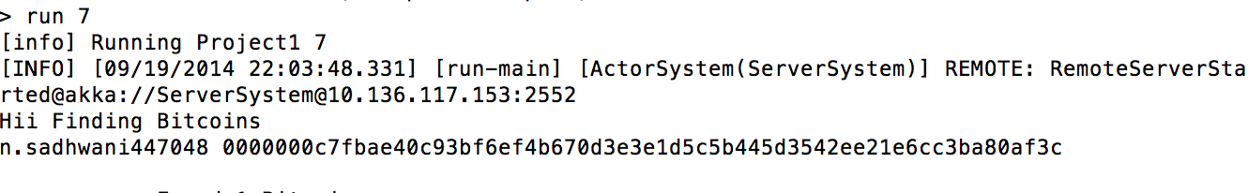

n.sadhwani447048 0000000c7fbae40c93bf6ef4b670d3e3e1d5c5b445d3542ee21e6cc3ba80af3c

**-----------------------------------------------------------------------**

Running time for **scala Project1 5**

**-----------------------------------------------------------------------**

The configuration of the machine I was running this code on was :  
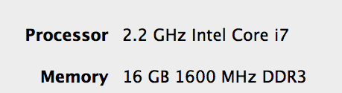

This was a quad core machine.

**Workers = 12 LeadingZeros = 5**

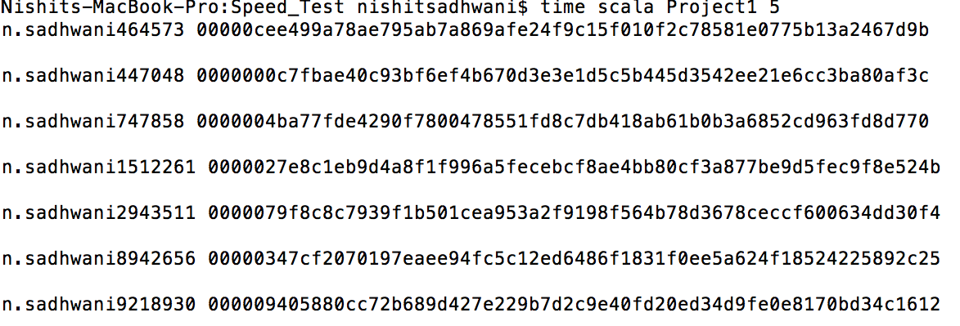

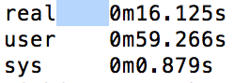

Number Of Cores = (user + sys) / real

= 60.145 / 16.125  
= 3.7590  
~ 4

**----------------------------------------------------------------------**Result of running the program for **scala Project1 4**

**-----------------------------------------------------------------------**

> run 4

[info] Running Project1 4

[INFO] [09/19/2014 21:57:37.773] [run-main] [ActorSystem(ServerSystem)] REMOTE: RemoteServerStarted@akka://ServerSystem@10.136.117.153:2552

Hii Finding Bitcoins

n.sadhwani47814 0000e856e1d7ea75bfc994fad4e3ce86bc5e2003ccb4b80e219e27c891dd7f64

n.sadhwani8116 0000e29a1debad94fdc1fff9e8ce23dfb71def835046c27aada701bd7dbf06e5

n.sadhwani247370 0000cedd2abb1fa0a074d393d8976a5625757fa50d7233a186dceb76f55f7626

n.sadhwani338300 0000daa01c62e6e7594964531b91b95a55ce2f156ce2226f3a6c18de8aae1cc0

n.sadhwani373125 0000b91849439f91f971efe433f733648f7568f860df13b8154499e1462314bb

n.sadhwani391055 0000db2193e378e0299b99bb3f7ca22c475f74ab5b3a0bb422cd91c29d9d5be7

n.sadhwani464573 00000cee499a78ae795ab7a869afe24f9c15f010f2c78581e0775b13a2467d9b

n.sadhwani447048 0000000c7fbae40c93bf6ef4b670d3e3e1d5c5b445d3542ee21e6cc3ba80af3c

n.sadhwani543132 0000c48a0f5cc04ecd89293723259430b86a8dc8292617e4efe909d4d3cba487

n.sadhwani595669 0000295f684b7f3c02e4f1f0af873f83430638dc83b4bb7c4ff1650d03f8eba1

n.sadhwani634092 000064f34af3582f8de1581845cb94de551edf6cb4e8200ff21c76cff0323f87

n.sadhwani747858 0000004ba77fde4290f7800478551fd8c7db418ab61b0b3a6852cd963fd8d770

n.sadhwani821097 000030ed4b420ae88a8a096bd7772ff1bac80a1dd84b2a3a2c99dbd909a1ff60

n.sadhwani865748 0000dc300884c9f05f1404b40bbc778f02bcfae936a5e230e1a019d7e20d1369

n.sadhwani903703 0000648fb7aa81d787b741e9370f339b4cb0f7c55f27f0a0abc8c4eebda7de45

n.sadhwani1019648 00006e32c53ac5508fb738cd3891525d7ce2b1cec2d6e7f5a6f9b1cc1a99a3d3

n.sadhwani1312498 00002e9d98488f1855d7ca41d3348d185d8dc0f8fd28c1e14b86c5ccfe326bbe

n.sadhwani1427457 0000ee918fbcfbf01375f9e32503966cdbe1997ad1f0ec8f8802e690bdc308cd

n.sadhwani1512261 0000027e8c1eb9d4a8f1f996a5fecebcf8ae4bb80cf3a877be9d5fec9f8e524b

n.sadhwani1476868 0000b9c40d915d22243c817562112d76315634b496e532a29b2a67024d4f00a9

n.sadhwani1590181 0000454f7cd2a837b8560e2b3874f1d40a1245c65d0bfa5add1f862a7ad2aece

n.sadhwani1630670 0000c8e27d886774b3758dac98d4646f29bd9e4846fbb49c6b1484f152a56787

n.sadhwani1590181 0000454f7cd2a837b8560e2b3874f1d40a1245c65d0bfa5add1f862a7ad2aece

n.sadhwani1597494 0000664251843d03af3172535ff08d1a2d0045445eb8ec0898e62bce4476a54b

n.sadhwani1753335 00002265c466031e0bd84985f4cdc4eb3183ad2620efeccbe2a5097b4d17a1b5

n.sadhwani1773677 00001add66fcd09594a892e9ca026cf72a8dbb56b158b664a7f31a9f2a4a911c

n.sadhwani1676956 00003f47e1c416e4de896f10e9f22ef3276dc03bf3564b0ff5275bb27cc3a2bc

n.sadhwani1810844 0000fd7f4f8c3c7bdc15f6ce2393c9247bbbe4204fd9c668e005b514c0388f1d

n.sadhwani1744963 000033cdc1b0ca5a4219c24b9ead6a6ef8ecaf8fdf91267087c87894465d7238

n.sadhwani1802848 0000861b157aca4398e08fea071797c2a3b90e2f8f72024825e47a4982d643f5

n.sadhwani1960528 0000970e1b761ac6c664f0948ad54b46e4c6820fd107b55118973cd7a30c6c25

n.sadhwani2301531 000072cc6922a44fe65fdb6f2506d91cf714a5c7d1e9148c7e77d42dd13bf957

n.sadhwani2375425 0000169848a7d4b82dcd1297949e1c62dd7d9c0932485aa05f2d389ed7fcf755

n.sadhwani2430689 00004dd3bbff19dfdfcaafc02dfeaf7e984a522dd18accdfbe29e10e82d11eb4

n.sadhwani2422047 0000547c8e47a84550b9ff14e6afabda962f8371466a7dedaf2a19a95fe5cfba

n.sadhwani2399671 0000f7c97d5e38484302e89e94361ff683a11ecd3823c43fdff0fce9304d2c11

n.sadhwani2596619 0000c2a6d2f13bab4f4b24b004f8aadb18118cda7178012f496977cffde83502

n.sadhwani2608582 0000a28c7c23e76e85ba9308cabaff98f48752577c2234b9d2851e3b2df3fc55

n.sadhwani2649493 00003d1affd4fe25af0f98c68fe0ee6a8ee44274506fd4f8153f5e0d8b0fd4a7

n.sadhwani2748814 0000ae1b2d4028d04293c0fdc8c1eae5afeadc828c78a1379a67df1b008b9c53

n.sadhwani2817042 0000450af831693d78b3546b5da6e1e795c79525f9b94d0a965e51cd223a54d1

n.sadhwani2892401 00009fdfd8b2a869204e897b484e7db43e29436345767778ec719a3fdaea4993

n.sadhwani2905302 000053c736b805c8259936889f3ce301236d4ffa953183065a815e0a00c0167c

n.sadhwani2943511 0000079f8c8c7939f1b501cea953a2f9198f564b78d3678ceccf600634dd30f4

n.sadhwani3042787 0000703c61aa7788f24b4db03e65e0e1b6cccbde966ff5685eb16cf5d2154ff0

n.sadhwani3091439 0000f09cba07cf627e859c52b5dc5e6fcca66921e6f5ce8da21ac7cbfbb594c4

n.sadhwani3150562 0000d7b397231302c47d9abf4c768bda324f5ae50edfb6abfcca35eb679f6524

n.sadhwani3163021 0000e5e6fa515cce908a818177288aad0295a2120d558d812937a81b72083e31

n.sadhwani3323439 00006089106483347edb9f1da094d055c58084a0b70434f825c120e8ca4b70d3

n.sadhwani3323439 00006089106483347edb9f1da094d055c58084a0b70434f825c120e8ca4b70d3

n.sadhwani3323703 0000a96389bc4b602214bad0111d4386f6803dd5fdf167d88c367a7a3a4c4b86

n.sadhwani3482548 0000957ea72629ee27aff1bab34e0776691e696f7634809e92356d3c58620806

n.sadhwani3550958 0000c242e298718bf7beebefb69fa25809e6ca52606b9a74f37224180c2dc94e

n.sadhwani3537298 0000c84835b7a56978d21ed11435b37515f3b7961406aa8d20de237ca6d137bd

n.sadhwani3721666 0000747221772710db25df7cf3cecaca6c2515e009b33b07e3d6d9523de29b0a

n.sadhwani3721666 0000747221772710db25df7cf3cecaca6c2515e009b33b07e3d6d9523de29b0a

n.sadhwani3725173 0000e64545582778f75491c0b56c5e204e445995a50fc5a732d8d63f3edbd078

n.sadhwani3795542 000075b8ef1333a864f75ed67d160f090e0a8a7b0b4ed69660573313b483adb6

n.sadhwani3968686 000077ecae4d298e0d4720587131139dcc4fe5b18f6be65f1759557ac85f4bdc

n.sadhwani4004025 000018961c1c5e2f97c532312cf0a338fd956d6fb7213368047d347f6ad7239e

n.sadhwani4097020 0000907f17afc38ef83f31568424c423ed77cd67d033955a344a4b12a9bc2ac6

n.sadhwani4150484 0000b7e19cec2e95c05fe08bd0193b02fae484714d461973928dc612457f8849

n.sadhwani4097020 0000907f17afc38ef83f31568424c423ed77cd67d033955a344a4b12a9bc2ac6

n.sadhwani4098956 000055459b8a1ddb4e0703fe4577359663f81f7f2ed0b42bfd85900774bad41d

n.sadhwani4200842 00007250a993820925b26fca369bc24384b650ff1583259c8c326f2c8a2fb5ec

n.sadhwani4211603 00001f99085d70ad29e0da77cef4f0e967d3a9555867e71e51126e76c057b3a9

n.sadhwani4127773 00009311cf3fd906bec766627bc592c92931f16df35de04016b7332e11d196cd

n.sadhwani4255111 0000869184497635bacde1f9476d8750762641d336cd3ad0b7024ad30385ab5a

n.sadhwani4225763 000012b2b2b3feffdfcd3c055ccd57d27b35acc41b59cc5efc6b720bf153233a

n.sadhwani4372788 0000235d2d6996d7657b703a98f325a355a1430aa7032a5b002a07d0fffd6e06

n.sadhwani4387689 000044b8a5cb045c09a1aad242840bff6a1a4a7ef4655c1fa6a75b1222d612d1

n.sadhwani4416314 0000ea0d815760c8ec3950d606518b9985898d0ab0240b7a8fc7f25574308855

n.sadhwani4453556 000051aa1391d3322d473a99bc794e6acc79c6a503b55a4f09f4ad007dea6c56

n.sadhwani4433370 000088266233a562662403537969e5bd102cc080f6248282673dc751c0d27b40

n.sadhwani4469339 0000447cee7f9b029e0bf2453779ab0f4ee83c37bfbacae7187a7f74aaee3ac3

n.sadhwani4545060 0000504bd4d56efb1d0311163fd771d6192a6d42544f37398ceba3a7fe89953f

n.sadhwani4661627 0000debf8c41c01af516c57fcc061f167950fc15757b9e3ca6a0d841fcb177d3

n.sadhwani4700502 0000c0b2b5fb096bc319f12be69a6aa299f22ffca2e67e950298c9bf2698c2fb

n.sadhwani4619138 00003df50bd6b244228a00edec67f4b69ad2b2e830cb54eddc8c613624ad2daf

n.sadhwani4732667 0000d1dcf94d78ea625c1c64cf9355c253671377867dc313349b13fbc29f5c2e

n.sadhwani4755002 00007e42ab7a07e1fcb6169d719e0eaaefb6ea9e6d7b5e43e3f20383c88f2abc

n.sadhwani4767589 0000240d67aaeeca8625d2f7e91b835bbccb9c0f9f6e40bf4fb4828be4638f41

n.sadhwani4913259 0000c7fdafec5a7e6ebfc38afdda546d4251398e58df0ec5239cfa6ef562fce6

n.sadhwani5166903 0000675d55cd2a1883be417dc3f6a0c61d0513a20a41b1ea20192a21c95e6604

n.sadhwani5214719 0000204a5e76eb44d81970dd722dd6f49de014503ed575c09622c402feead42a

n.sadhwani5214719 0000204a5e76eb44d81970dd722dd6f49de014503ed575c09622c402feead42a

n.sadhwani5216173 0000a098eca90b1d95ef92d822dca2288e77328116cc673c786740caafe2c2e6

n.sadhwani5352300 00002ce0ed55dd57b007f9dc7297d3a146ef2a2d0a0da97b71149046d8fc0d69

n.sadhwani5424457 0000f40b343584b401b1d345366753bcce876599816f208e217b3b5bd847a84b

n.sadhwani5374634 0000d253d0ed233d97866ab545841a90aef11bd5d6cff119b216d0d92c2b9d69

n.sadhwani5528721 0000b40c822f21886b9d6955b303748d9d8002f47ce322af57da3e95cf081827

n.sadhwani5662368 0000c6af852a31e6aeae6cad9d3c61946dba538890a2b01a113d6a27b0a536bf

n.sadhwani5720676 00003f9730c741cce682fdfdc93acee7086f8f0e34d5ff91021214ef3a77a322

n.sadhwani5731220 0000489fe83938f93f3a0690da9645941d8b328b91ee7cf0a9dcfb45c45098bb

n.sadhwani5689877 0000977af75b5e2e8ef66b553a5b86288dcea5cfca1d72e47ddce50fc95831c6

n.sadhwani5808269 0000d21caa6f37239bb4310bff356b46b76f37787cd8f5aaed636cb3c8bfe3a5

n.sadhwani5891116 000042fa78afafc9daa436030a560bd06d4f19af42e5c86c578ff9211edfbe95

n.sadhwani6216564 0000620c30f2642bf76d86ca74e606f102b999b379d669e311b28803bb7e6603

n.sadhwani6238894 000055d016bbffd48e300aa82a44689b4f6153dae3c47b62ce429b52b3f11f15

n.sadhwani6266124 000089270d873e24c91fa43e405b2e9622bf1f07fab6791dd6dadcec832c94c0

n.sadhwani6393456 000049d6e80cdffb48b003aaf9facf88d6c1beb4bbd7ae8dd60c8108ce723bfd

n.sadhwani6462045 0000e0d0f1d659622e242bf3338da4088c08fd364a52e27434491d9d728cf68e

n.sadhwani6513923 0000807adc57ec449d9b82c8a6be621fa8b50d407144ba56ae8678ed8a432703

n.sadhwani6538508 0000df91a22f87b54d6a70e12919242db8794b22c14d7bd074d6b4cd641fb69f

n.sadhwani6584560 0000d9ad9cfaadf2ebcf9bff84a9fb6733e2b0ade47b21c633166dab95076fe7

n.sadhwani6649864 0000a48dd9275ec4c851c1945573e206536d3e4f3c8cfc9fcb8868e2bb96c78e

n.sadhwani7014228 00006193a996d20e2b606dd59363411349f9fa78b529f81ce392d5c42927bcae

n.sadhwani6955786 0000d02ed08c7326c0c6a618ce0c8aaefa7235d17f4fc14e70941b4844d92d50

n.sadhwani6955786 0000d02ed08c7326c0c6a618ce0c8aaefa7235d17f4fc14e70941b4844d92d50

n.sadhwani6956038 00004fae4efb1a5d29b7f8e7954299cb6ed49eed2a0c5eb7052624ce7db903fd

n.sadhwani7064366 0000716d4883819627c9378a1b6981d666934327e2a682fe20db8f3d9a0034b3

n.sadhwani6968923 0000299c174f1c80ffd834c19a0dca02fbcebce62bf3911f23b831b98f60c4d6

n.sadhwani6989054 00004e0d67ecc967a0d74763555b11ab2f1df2b64b8175db8131f99d33ef0294

n.sadhwani7058727 0000be5f304e6760403e76c808d1f3fc0fd9b098c874112b1f9d8ff6820519ab

n.sadhwani7172910 00007b1bffbdda12695088f35dbc884cfafca006ad6dfd3879841c780808f59c

n.sadhwani7183743 00008fe02da05eaf026d456e4e3351db779fdc4aef335271a125a430551b4169

n.sadhwani7272471 0000cad3d30469d5c2655f22273c76b6abea5bce1235b4c81c3230dc93cd3fcf

n.sadhwani7313352 00009ca326477244596bced9dc5feae87e79047313c8c59fe012f06484d7bdd9

n.sadhwani7461625 00004adbbd35aba37064edfa70ae907ad3ce18596e82e4a29d1b66557b199b22

n.sadhwani7680546 00001a15d56256e0447cccf3794dff081a032414c9b1af1e842412c705180f85

n.sadhwani7653258 000083dee69515f96355993ef42a23a4aae7907a65a695f2d47a642241cde1ec

n.sadhwani7899809 00005ed910cde1832f3c24dc2e0c089fee7df17995012a50e612ebdf25943c07

n.sadhwani8046283 0000bbd4324216f1d14a6b0cb86feeb3a4d0cbd4f047b2f1d1489b46546cfe14

n.sadhwani8113140 0000eb3823ab5fe66e9f03475863386f92dd3e6f00d4664d292df1bdb8d30844

n.sadhwani8154471 000045cf19859b60cc238007a2f1bee635713d6e0dd7b917b877ac3f83761111

n.sadhwani8291373 0000e9245da7d1abfa0289b7acb91b7f0645f747dd434f2e30b12dbdb6e5a142

n.sadhwani8513549 0000c4978a41f1bb3b20e7b17f9a0f4a7afa3a37fd36165ce5ac0fdade0c8f2e

n.sadhwani8590267 0000e2c4b13c2583940eceb24d6575607cd556e9db9e6ddf9ca3c44c7e8be6e3

n.sadhwani8633595 0000ae9f9bea171bd6dbc9c8cf5ee9c8498ff2a15cd3730c386c1e85b9d171d7

n.sadhwani8633595 0000ae9f9bea171bd6dbc9c8cf5ee9c8498ff2a15cd3730c386c1e85b9d171d7

n.sadhwani8637084 0000f8b92b1b54221af2b960c02f7218196ba1ed4f0dd2897dae1937f221be51

n.sadhwani8688729 0000cee5d369c9362137c4c756fdbcb8a2ffae97204065c776dc97e2ca329cce

n.sadhwani8942656 00000347cf2070197eaee94fc5c12ed6486f1831f0ee5a624f18524225892c25

n.sadhwani8970753 00008cee0e300104bd38981d770c81108620aaa7f5fd398897d70a0e063e3ba6

n.sadhwani9218930 000009405880cc72b689d427e229b7d2c9e40fd20ed34d9fe0e8170bd34c1612

n.sadhwani9238320 00007af0c7bfcf688650bbccb0ca12f6e713865bdb7d767f8ec597f7d575f120

n.sadhwani9433293 000038011bd61c14bd4408504e876da155aa427826755ff7f30f4fa5b62c4ebc

n.sadhwani9531334 00009a1272a5b44eef6895b59538901e20210f15b13bc1fa627dc623b772b0d6

n.sadhwani9504789 00006092b641c57f49416386f04e453d4c255622643ae226f197a4610c374dcb

n.sadhwani9552085 00007a74ee6e97f2200481d1c54ace88c182af85f78d628783f1fd062c7b9f96

n.sadhwani9573439 0000f471a13c810af615698d7d7bb76ea78b9ec5782a71a5f5c231cef896df32

n.sadhwani9528045 0000a4dedac44e0b9924bd9cdc431cd7d8e46b394441a84360d3e476dbb8f150

n.sadhwani9672196 0000f7c45d0d107c826cfae5bab72812e101ab5de8b275f01086880c46898a26

n.sadhwani9628304 00006298a00b21b4be1197afb5546d139e738ed9089c9efda0d7a8c1f948aa9a

n.sadhwani9797378 0000d920124e18a8d77346003be2f141c0c50af0416f1910dba26d9c1d9e7852

************Found 138 Bitcoins**************

.................Terminating...............

**-----------------------------------------------------------------------**

Largest number of working machines

**-----------------------------------------------------------------------**

The largest number of machines that we could test the code on was 4

**Server Screenshot** :

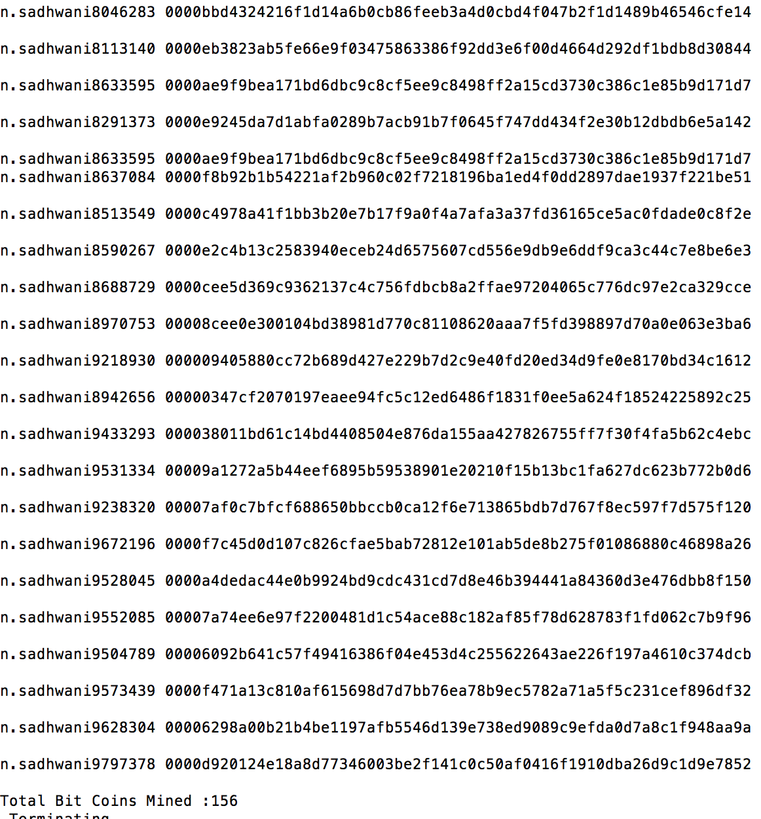

**Client Screenshot :**

